**EQUITY**

**RESEARCH**

**REPORT**

**GODREJ CONSUMER PRODUCTS**

**BSE: 532424 | NSE: GODREJCP |ISIN: INE102D01028 | SECTOR: Consumer Goods (FMCG)**

Godrej Consumer Products Ltd (GCPL), a flagship entity of the 126-year-old Godrej Group, is a leading FMCG company with a robust presence across India, Indonesia, Bangladesh, and several countries in Africa and Latin America. With a 126-year legacy of trust and innovation, the Godrej Group has built deep-rooted consumer relationships and today proudly caters to over 1.4 billion consumers globally across diverse geographies.



**Consumer****Products**

Godrej Consumer Products Limited (GCPL) maintains a strategically diversified portfolio spanning key FMCG categories such as pest control (Goodknight, HIT), home care (Godrej Aer), and personal care (Darling Zuri Braid). On May 8, 2023, the company completed the acquisition of Raymond Consumer Care Limited (RCCL) through a slump sale agreement signed on April 27, 2023. RCCL, with established brands like Park Avenue and Kamasutra, strengthens GCPL’s presence in the high-growth deodorants and sexual wellness segments. This acquisition aligns with the company’s strategy to expand into fast-growing lifestyle categories and complements its existing footprint in perfumes, supporting its broader vision of holistic consumer wellbeing.

In FY24, Godrej Consumer Products Ltd. (GCPL) posted a 7% YoY increase in net sales, reaching ₹14,096 crore, led by strong performance in the Home Care segment, which grew 12% to ₹1,016 crore. Personal Care contributed ₹1,176 crore, registering a modest 3% growth. The branded portfolio rose 7% YoY to ₹2,192 crore, while Unbranded and Export sales surged 21% to ₹86 crore, reflecting growing diversification.

GCPL’s portfolio remains well-balanced across price tiers. Its ₹1,000+ crore brands—Goodknight, Darling, Godrej No.1, and Cinthol—anchor its leadership in core categories. In the ₹500–1,000 crore range, HIT, Godrej Expert, Aer, and Stella continue to drive category momentum. High-potential brands like Ezee, Mitu Baby, and Mega Growth in the ₹200–500 crore bracket are steadily scaling.

This tiered brand architecture positions GCPL for broad-based, sustainable growth across consumer segments.

**FINANCIAL INFORMATION**

|  |  |  |
| --- | --- | --- |
| **INR MILLIONS** | **FY24** | **FY23** |
| Total Assets | 1,84,960 | 1,74,990 |
| EBIT | 27,030 | 21,940 |
| PAT | -5,610 | 17,020 |
| Total Revenue | 1,40,960 | 1,33,160 |

*Source: Company Annual Reports*

Godrej Consumer Products Ltd. (GCPL) reported a net loss of ₹560.6 crore in FY24, reversing from a profit of ₹1,702.5 crore in FY23, largely due to exceptional items worth ₹2,476.9 crore. These included goodwill and brand impairments in Africa and losses from the divestment of East African operations.

Operational performance, however, remained resilient. Consolidated revenue rose 6% YoY to ₹14,096 crore, while EBITDA grew 21%, driven by healthy volume growth and margin expansion. Organic volume growth stood at 7%, led by Indonesia (+11%) and India (+6%), with international markets contributing 41% to topline.

EPS declined sharply to ₹6.33 (vs. ₹14.80 in FY23) due to the one-offs. While core fundamentals remain strong, near-term earnings visibility may be tempered by restructuring-related headwinds.

down effects.

|  |  |
| --- | --- |
| **Price to Book Value** | 10.78 |
| **Dividend Yield** | 1.96 |
| **Return on Assets (ROA)** | 15.02 |
| **Return on Equity (ROE)** | 29.83 |
| **Return on Employed Capital (ROCE)** | 16.79 |

*Source: Company Financial Report*

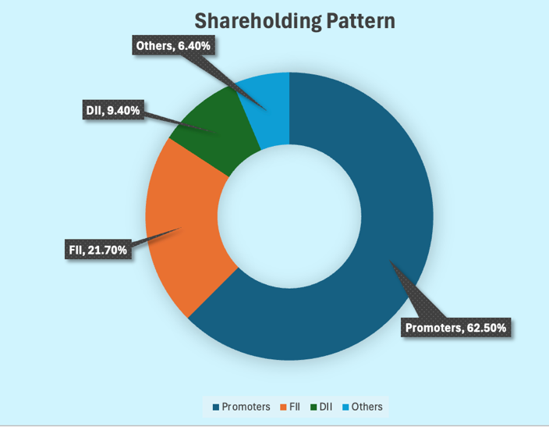**SHAREHOLDING PATTERN**

*Source: Company Shareholding Report*

|  |  |
| --- | --- |
| **Majority shareholders** | Promoters |
| **FIls** | 21.70% |
| **Mutual Fund** | 5.56% |
| **Promoters with Highest Holdings** | None |
| **Pledged Promoter Holding** | None |
| **Largest Single Shareholder** | None |
| **Individual Investors holdings** | 4.06% |

**SHAREHOLDING COMPARE (% Holding)**

|  |  |  |  |
| --- | --- | --- | --- |
| **Majority shareholders** | **62.5%** | **63.21%** | **-0.7%** |
| **FIIs** | **22.56%** | **23.72%** | **-1.16%** |
| **Mutual Fund** | **5.56%** | **3.88%** | **+1.68%** |
| **Insurance Companies** | **2.21%** | **2.41%** | **-0.20%** |
| **Non institutional Investors** | **5.05%** | **5.71%** | **-0.66%** |
| **Other DIIs** | **1.42%** | **1.07%** | **+0.35%** |

*Source: Company Annual Report*

**COMPARE VALUATION WITH PEERS**

|  |  |  |  |
| --- | --- | --- | --- |
| **Company** | **P/E** | **EV/EBITDA** | **PEG RATIO** |
| **Nestle** | 55.5 | 37.0 | 7.75 |
| **HUL** | 57.8 | 38.0 | 6.09 |
| **Dabur** | 52.8 | 52.5 | 17.3 |
| **Britannia** | 64.6 | 57.1 | 6.55 |
| **Tata Consumer** | 81.6 | 66.1 | 5.55 |
| **Marico** | 55.0 | 48.2 | 5.85 |
| **Colgate** | 62.9 | 50.4 | 3.77 |

*Source: Company Financial Report*

GCPL continued strengthening its go-to-market strategy through Project Vistaar, expanding rural reach by adding 300,000 outlets and tripling village coverage. The Raymond Consumer Care integration brought in 100,000 chemist outlets, significantly boosting the Sexual Wellness portfolio's accessibility.

The company reported strong penetration gains—over 500 bps in hair colour and a 25% rise for Goodknight Liquid Vaporisers. Modern trade and e-commerce saw a 10% increase in active outlets, aiding premiumisation. Customer engagement remained robust, with NPS inching up to 51%, surpassing the 50% benchmark.

Advertising investments crossed ₹1,000 crore, elevating GCPL to the 5th largest advertiser in India (from 17th in 2021), underscoring its commitment to brand-led growth. Looking ahead, the company is well-positioned to sustain momentum through deeper rural access, digital and chemist channel acceleration, and continued brand-building to reinforce category leadership.

**PRICE ACTION**

|  |  |
| --- | --- |
| **Parameters** | **Range** |
| Volume Traded | 8,58,307 |
| Current Price | 1283.15 |
| Face Value | 1.0 |
| Previous Value | 1300.05 |
| Open Price | 1308.90 |
| Today low/high | 1,277.20/1,319.75 |
| 52-week low/high | 979.50/1,541.85 |

*Source: National Stock Exchange*

India’s robust macro environment 8.2% real GDP growth in FY24 and an estimated 6.4% in FY25—alongside rising consumption, digital adoption, and sustained public capex, sets a strong foundation for FMCG expansion. The sector reported 10.6% value growth in Q3 FY24 and is poised for a 27.9% CAGR through FY27, driven by rural demand and premiumisation trends.

GCPL, with ~59% of its revenues from India and 6% organic volume growth in FY24, is strategically aligned to benefit. Initiatives like Project Vistaar, deeper rural reach, and stronger play in modern trade and chemist channels bolster its growth readiness. India remains central to GCPL’s long-term value creation thesis, supported by structural tailwinds and focused execution.

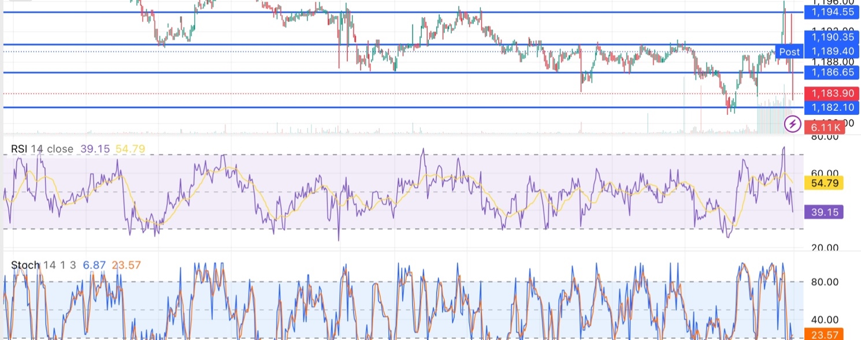

*Source: National Stock Exchange*

GCPL delivered a resilient operational performance, with consolidated sales up 7% YoY and EBITDA expanding 21% YoY. Segment-wise, Home Care drove growth with a 12% increase, while Personal Care posted a muted 3% rise. Unbranded products and exports stood out, surging 21%—reflecting strength across diversified geographies and categories.

However, the technical outlook signals caution. As of June 20, 2025, GODREJCP closed at ₹1,183.40, down 0.86%, breaching key moving averages and edging close to a crucial support zone at ₹1,182.10. A breakdown could accelerate bearish momentum, while resistance at ₹1,186.65 caps near-term upside.

Momentum indicators paint a bearish undertone—RSI stands at a weak 39.15, and the Stochastic oscillator (%K at 6.87, %D at 23.57) suggests oversold conditions. This could prompt a technical rebound if support holds, though conviction remains low.

While fundamental performance remains strong, the near-term price action reflects market hesitation. A decisive move above ₹1,186–₹1,188 is needed to shift sentiment. Until then, we advise a neutral stance with a watchful eye on support levels.

**Disclaimer:** *The views, analysis, and content presented here are for informational purposes only and do not constitute financial, investment, tax, or legal advice. They do not take into account your individual objectives, financial situation, or specific needs. Before acting on any information provided, you should carefully consider its suitability in light of your personal circumstances and consult with a qualified financial adviser, stockbroker, or legal/tax professional as appropriate.*

*Not all investments or strategies discussed may be suitable for every investor. The information shared is based on sources believed to be reliable and accurate at the time of writing; however, no guarantee is given as to its completeness or correctness. You are encouraged to conduct your own due diligence before making any investment decisions.*

*To the fullest extent permitted by law, the author disclaims any and all liability for any loss or damage arising from reliance on the information provided, including indirect or consequential losses, or data-related damages. Where such exclusions are not permitted by law, liability is limited to the provision of equivalent services as allowed under applicable legislation.*

*All information is subject to change without notice.*